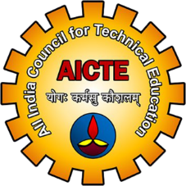
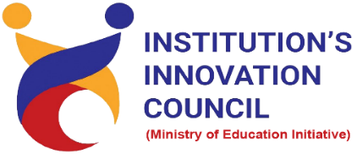
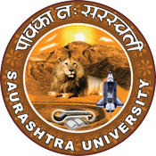

Entrepreneurial Ecosystem for Start-up
30 June 2022
At
Virtually on Webex
Saurashtra University Campus, Rajkot
Contents
Saurashtra University – IIC 2
Event Schedule 2
Event Registration Link 2
Brief about Event 3
Key Points 3
Outcome 3
About the Speaker/Chief Guest 4
Connect Us: 5

Saurashtra University – IIC
The university is dedicated to instruction, research, and extending knowledge to the public (public service). Ministry of Education (MoE), Govt. of India has established ‘MoE’s Innovation Cell (MIC)’ to systematically foster the culture of Innovation among all Higher Education Institutions (HEIs). The primary mandate of MIC is to encourage, inspire and nurture young students by supporting them to work with new ideas and transform them into prototypes while they are informative years. Saurashtra University is one the Organization that have constituted the IIC to foster the vision of MoE and be a part for the promotion and development of innovation ecosystem.

Event Schedule

Event Registration Link

bit.ly/ImpactSeries-IIC

Brief about Event
Saurashtra University is Organizing Impact Lecture Series with support of Ministry of Education, Government of India. The objective of Impact Lecture Session is to support students from hilly/rural/backward regions or 3rd tier cities by organizing impact lectures to establish a strong connection with the innovation and start up ecosystem enablers at the state and national levels.
The webinar’s objective is to gain insights about start-ups and entrepreneurship. This involves understanding funding needs like define the need of fund, size of fund required and utilization of fund. In this webinar discuss about types of funding like Business loan, Venture capital, Angel investors etc. Also, four stages of funding understood by the speaker. India also needs more entrepreneur for start-up growth.
After completion of the workshop, participants are able to acquire more knowledge on Entrepreneurial Ecosystem for Start-up.

Key Points

During the session, below mentioned points were discussed:
- Funding needs
- Types of funding
- Stages of funding
- Pros of funding from VC / AI
- Cons of funding from VC / AI
- Suggestion for start-up
- FAQs related to Entrepreneurial Ecosystem for Start-up

Outcome

As per the event, various types of Start-ups, Importance of Start-ups, benefits of start-up and Various Ecosystem for Start-up was made understood by the speaker.
Also, as it was related to Start-up so, myths like VC / AI are less risky, ideation sharing (NDA) and exit plans etc was made understood by the speaker in detail. A basic knowledge of how-to Start-up Ecosystem, how it works with various examples of Start-up etc.

About the Speaker/Chief Guest
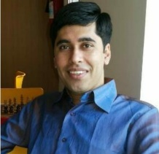

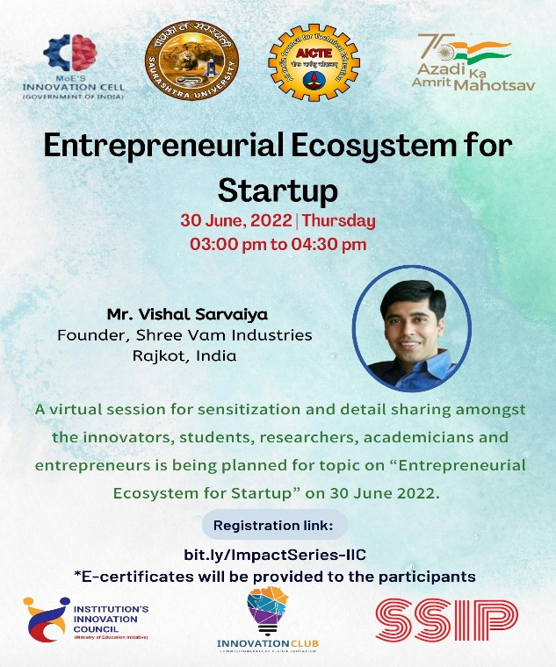

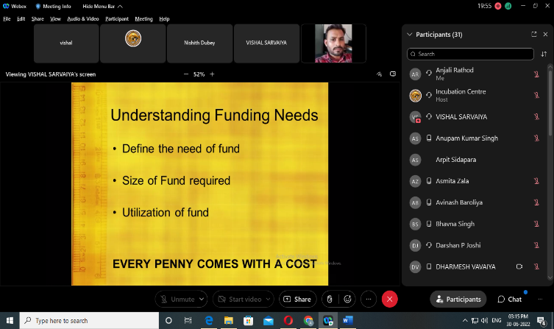
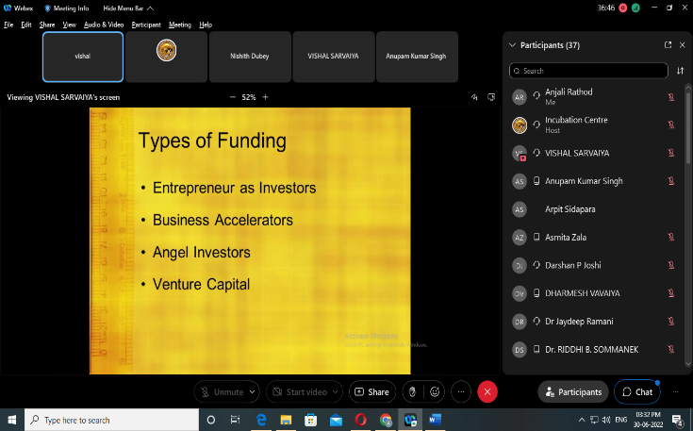

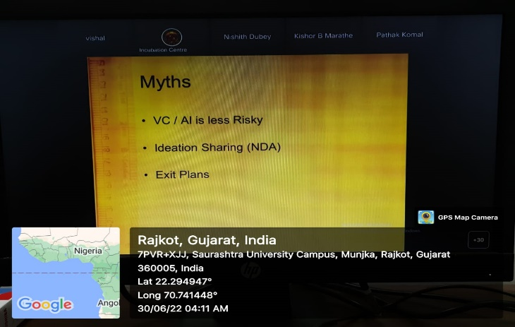
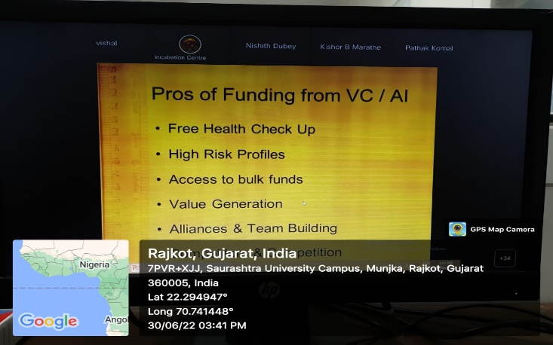
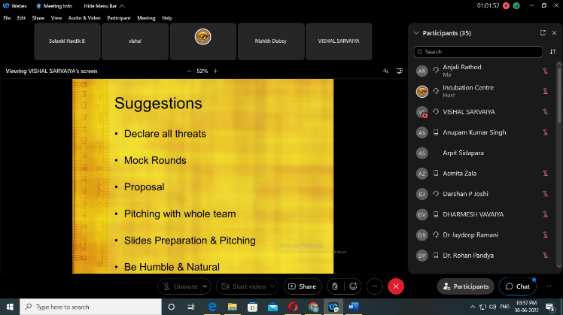

Connect Us:

https://www.linkedin.com/company/susec iic@sauuni.ac.in
https://www.facebook.com/iicsauuni bit.ly/SU-SSIP Location
https://www.instagram.com/susecrajkot https://bit.ly/SUSEC-youtube

